** REPUBLIC OF CAMEROON REPUBLIQUE DU CAMEROUN**

**PEACE-WORK- FATHERLAND PAIX- TRAVAIL-PATRIE**

**---------- ---------**

**MINISTRY OF HIGHER EDUCATION MINISTERE DE L’ENSEIGNMENT**

**SECONDAIRE**

**UNIVERSITY OF BUEA UNIVERSITE DE BUEA**

**FACULTY OF ENGINEERING AND FACULTE DE L’INGENIERE ET**

**TECHNOLOGY TECHNOLOGIE**

COURSE NAME AND CODE: **MICROCONTROLLER LAB_EEF 368**

***REPORT ON THE BLINKING LED***

LECTURER:

Presented by :

|  |  |
| --- | --- |
| NAME | MATRICULE NUMBER |
| **MEH ARSTRONG EWEH** | **FE19A063** |
| **FOMONYUYTAR JOSEPH** | **FE19A038** |
| **NDAH RUTH KAH** | **FE19A071** |
| **EBAI-NDIP BORIS TABE** | **FE19A023** |
| **FOUGUE NASSER NGOUANA** | **FE19A041** |

**Aim:** Blink an LED connected to a PIC16F84A microcontroller with MikroC

**Requirement:**

* PIC16F84A microcontroller
* LED
* 8MHz crystal oscillator
* Capacitor
* Resistor
* MikroC compiler
* Proteus

**Procedure:**

* The LED is connected with RB0 pin of PORTB of the microcontroller through a resistor.
* We build the circuit using proteus.
* Instruct the MCU that the PORTB pins are used as output.
* Make all output RB0 low.
* Write the code of the blinking LED using MikroC compiler.
* We run the code and a hex file is generated named led-blinking.hex
* After generating running the code and hex file generated, we go to circuit and load the hex file into the PIC.

**Results and Observation:**

* We run the simulation and the LED blinks for every 1s as configured in the code for a delay of 1000ms.

**Code:**

void main() {

TRISB=0;//PORTB pin is output while(1){ //Get into the infinite while loop PORTB=1; //LED ON delay_ms(1000); //1sec delay PORTB=0; //LED OFF delay_ms(1000); //1sec delay

}

}

**Circuit:**

OSC1/CLKIN

16

RB0/INT

6

RB1

7

RB2

8

RB3

9

RB4

10

RB5

11

RB6

12

RB7

13

RA0

17

RA1

18

RA2

1

RA3

2

RA4/T0CKI

3

OSC2/CLKOUT

15

MCLR

4

U1

PIC16F84A

C1

2

pF

2

C2

pF

2

2

1

2

X1

CRYSTAL

D1

LED-YELLOW

R1

R

220

**Conclusion:**

The led blinks after every 1s **Aim:** Blink an LED connected to a PIC16F84A microcontroller with MikroC using a Push Button.

**Requirements:**

* PIC16F84A microcontroller
* LED
* 8MHz crystal oscillator
* Capacitor
* Resistor
* Push Button
* MikroC compiler
* Proteus **Procedure:**
* The LED is connected with RB0 pin of PORTB of the microcontroller through a resistor.
* We build the circuit using proteus.
* Instruct the MCU that the PORTB pins are used as output.
* Make all output RB0 low.
* Connect a Push button to RB7 with through a second resistor.
* Write the code of the blinking LED using MikroC compiler.
* We run the code and a hex file is generated named led-blinking.hex
* After generating running the code and hex file generated, we go to circuit and load the hex file into the PIC.
* We press the Push button and observe.

**Results and Observation:**

* We run the simulation and press the push button and the LED blinks for every 1s as configured in the code for a delay of 1000ms.

**Code:**

void main(){

TRISB=0; //PORTB pin is output while(1){ //Get into the infinite while loop while(PORTB.B7==1){ // Press the Push button PORTB=1;//LED ON delay_ms(1000);//delay of 1s

PORTB=0;//LED OFF delay_ms(1000);//delay of 1s

}

while(PORTB.B7==0){ //Release the Push button

PORTB=0;//LED OFF

}

}

}

**Circuit:**

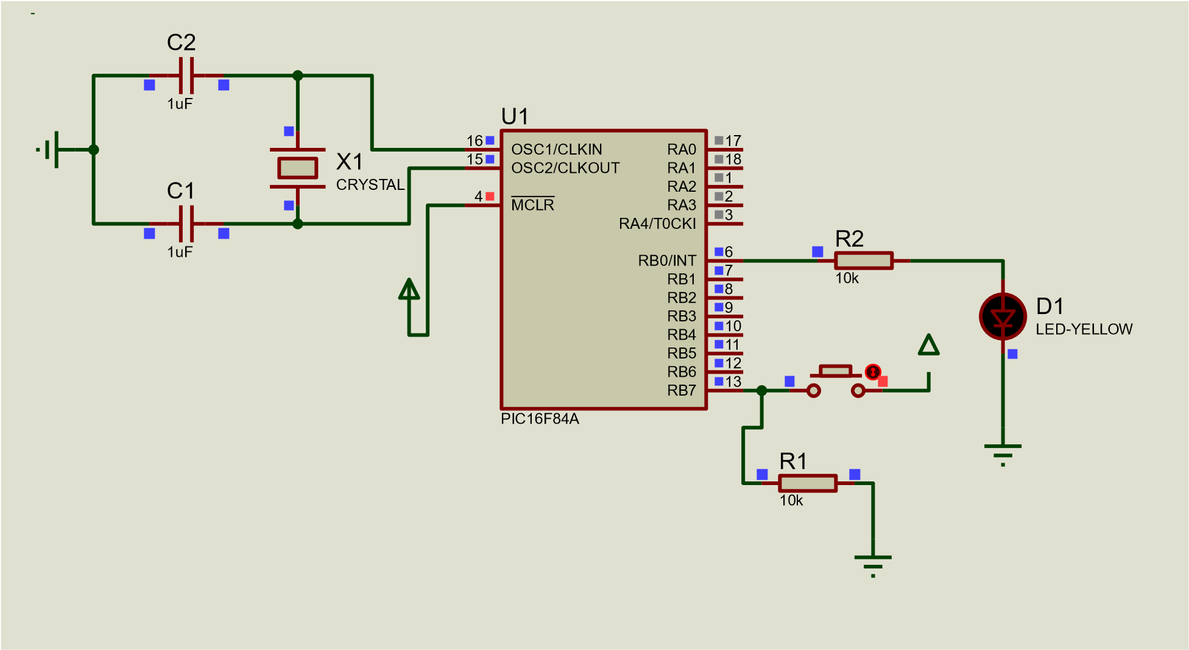

**Conclusion:**

The led blinks after every 1s when the push button is pressed.